Analyzing EEG Patterns in Healthy Patients: Insights into Task Performance and Error Perception:

The four tasks described involve investigating error-related potentials (ErrPs) in various contexts: typing tasks, human-robot interaction (HRI), and brain-computer interface (BCI) speller tasks. By analyzing EEG signals, these tasks aim to understand neural responses associated with error perception, facilitating adaptive behavior and real-time feedback. The ErrP graph plots, depicting average brain activity waveforms for correct and error trials, highlight variations in neural responses. These tasks hold significance for improving human-robot interaction and developing more intuitive BCI systems. ErrP pattern recognition is crucial for decoding neural signals and informing adaptive behavior in real-world applications. Importantly, these tasks can be applied to healthy patients to study cognitive processes, enhance human-computer interaction, and develop assistive technologies for individuals with motor disabilities or communication disorders, ultimately improving quality of life.

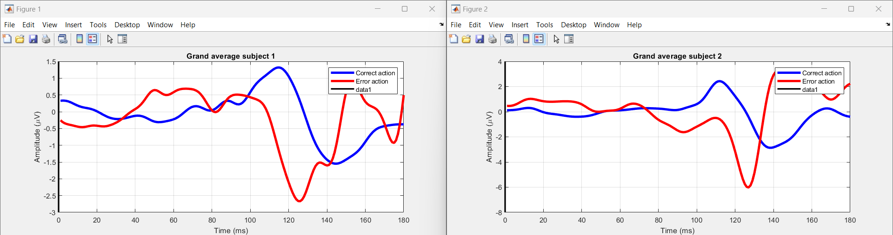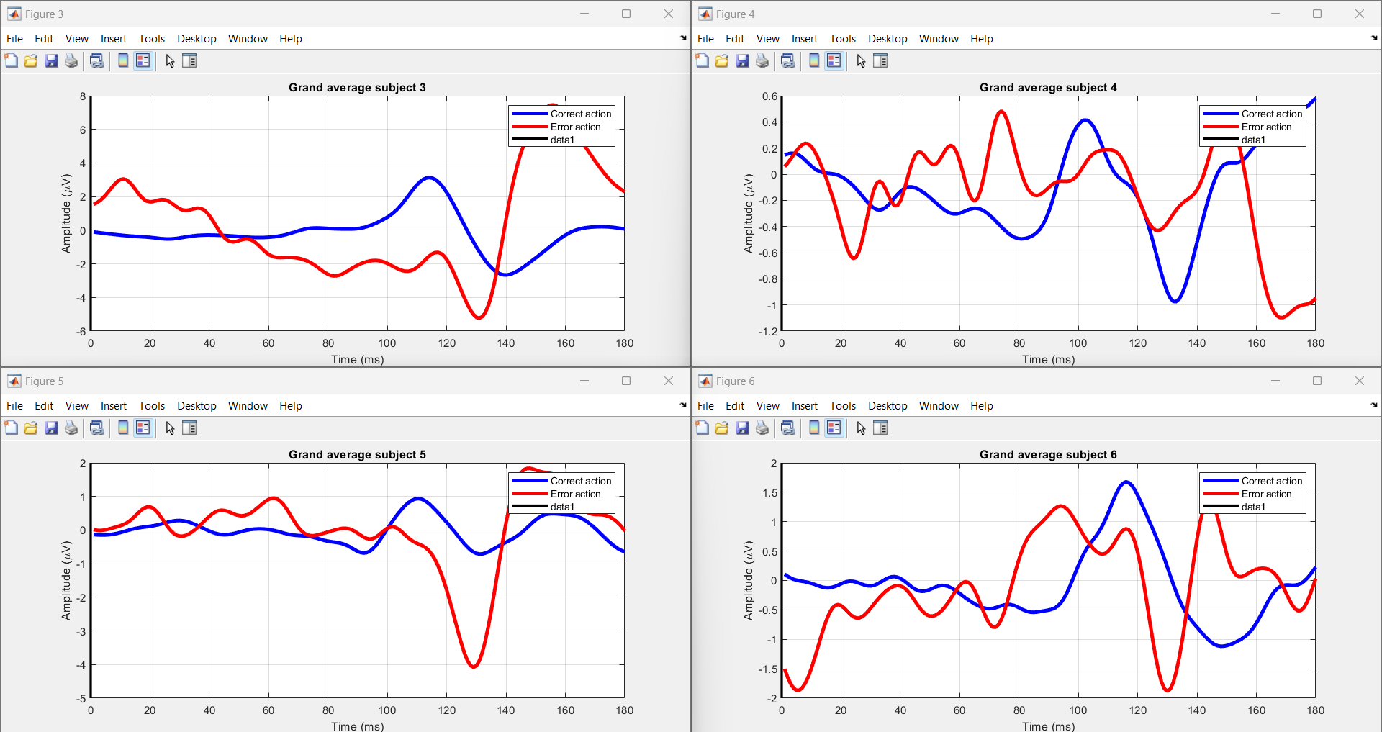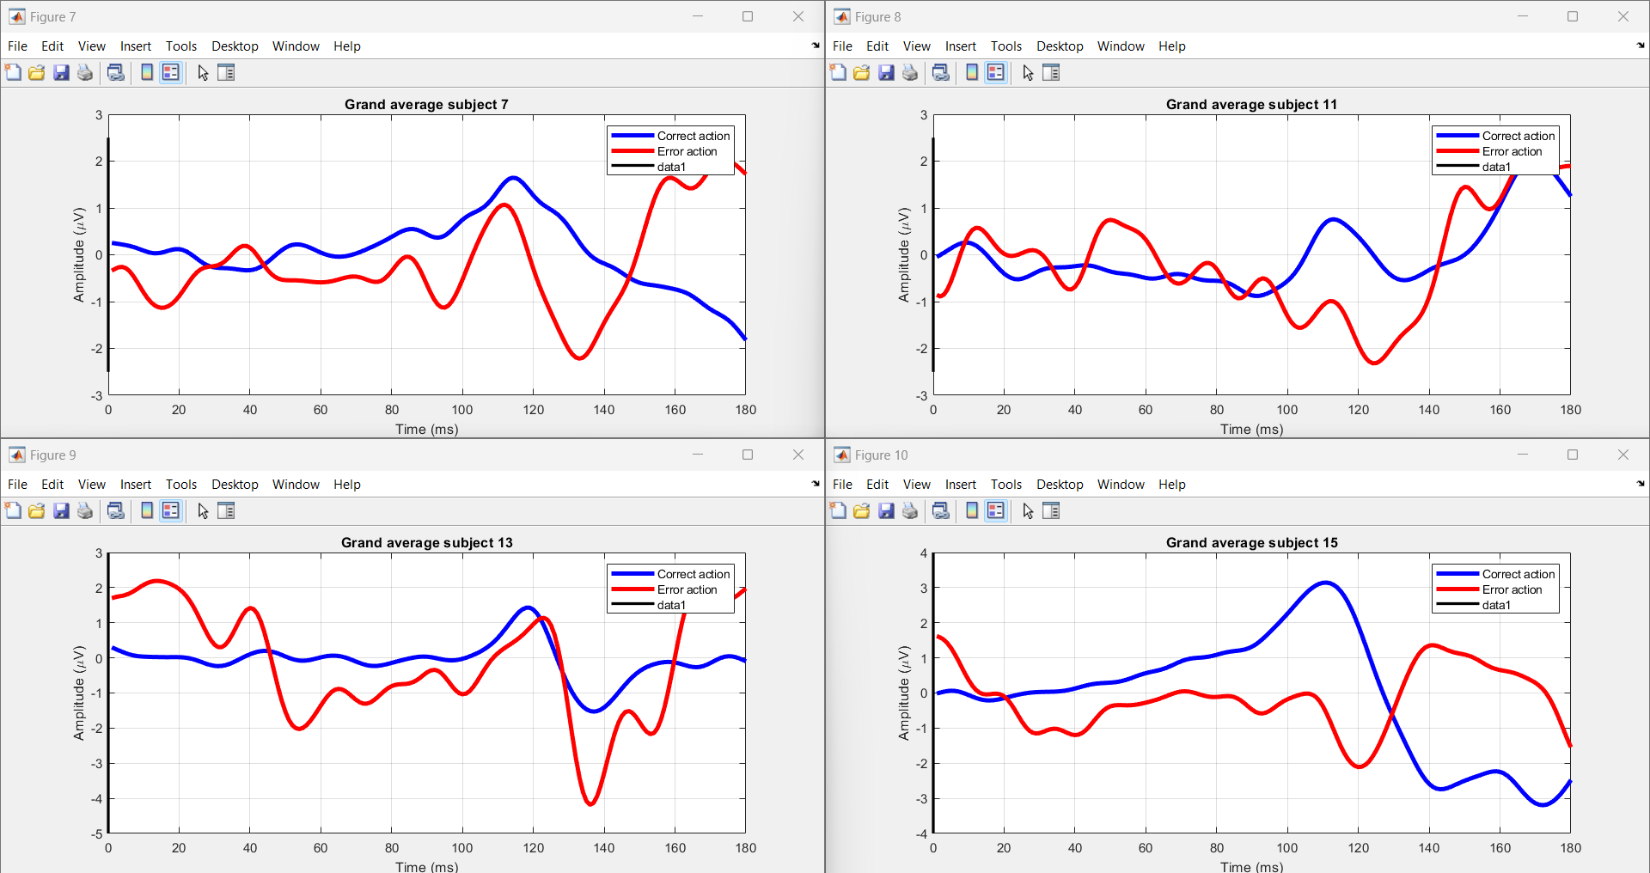

Fig1.Errp pattern Recognition by using Gaze based keyboard task.

The task at hand involves investigating the physiological responses associated with error perception during typing tasks(The graph will superimpose the average brain activity waveforms for both correct and error trials, accentuating variations in neural responses between the two). Each session comprises typing a sentence followed by a brief pause. Data encompassing typing speed, accuracy, and error detection are collected. The EBNeuro EEG device records brain electrical activity using 64 wet electrodes, while the SMI myGaze eye-tracker captures gaze movements on the screen. The Lab Streaming Layer software synchronizes EEG and eye-tracking data streams for coherent analysis. Segmented into epochs, data epochs capture physiological responses around key presses. Support Vector Machine (SVM) models are employed for classifying correct and erroneous typesetting based on collected data. The process involves data loading, preprocessing, feature extraction, dataset splitting, and training SVM models. Code functionalities include loading EEG data, visualizing EEG activity for each subject, and saving processed data into MAT files for further analysis. The study involves 10 participants, aiming to understand the interplay between physiological responses and error perception during typing tasks.

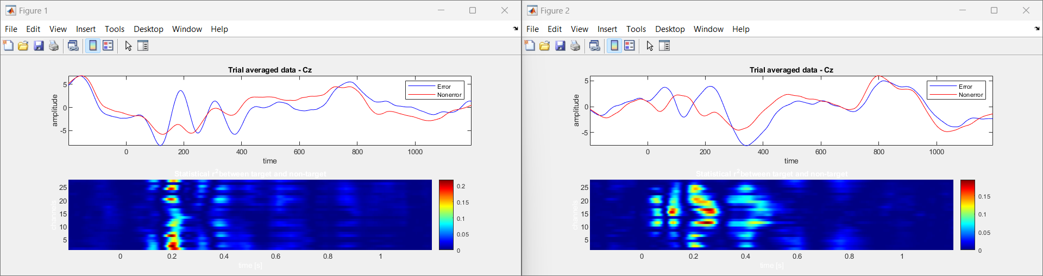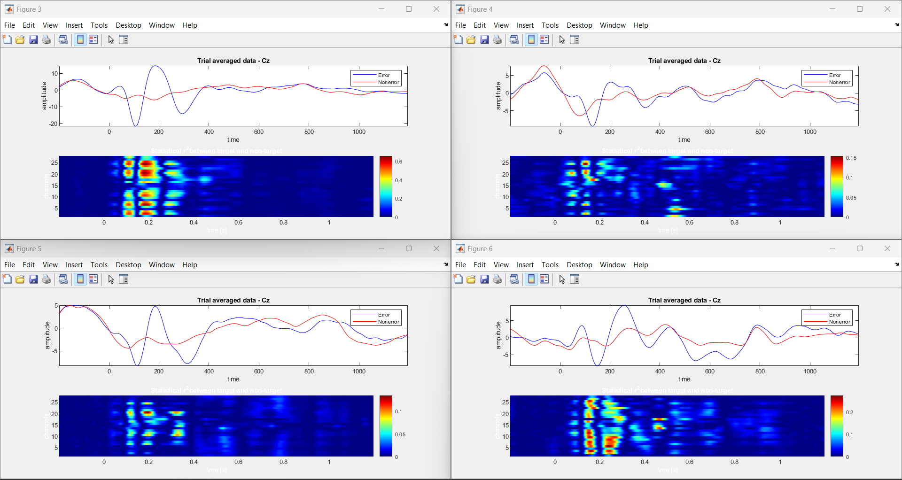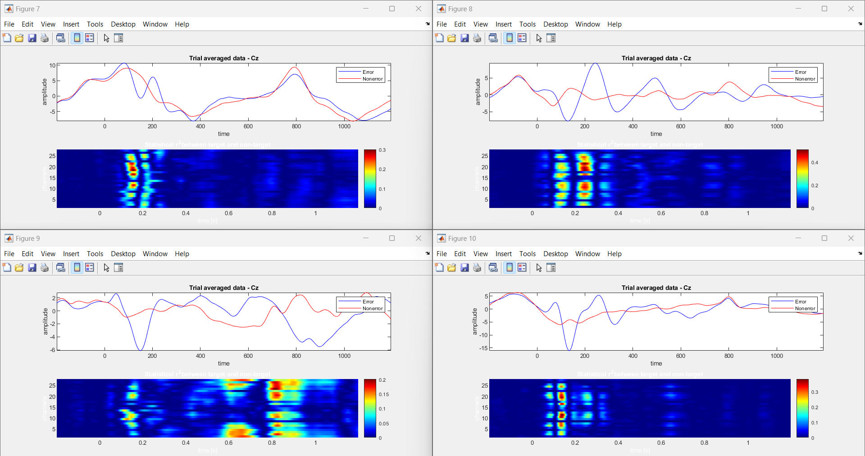

Fig 2.Errp pattern Recognition by using Human-Robot Interaction.

The Human-Robot Interaction (HRI) investigates EEG-based ErrPs (error-related potentials) during interactions with a humanoid robot in a simplified task. Using an ActiCHamp amplifier with electrodes, the study captures brain activity time-locked to robot actions. Advanced signal processing and high-quality signal acquisition ensure accurate data collection. MATLAB and EEGLAB are employed for preprocessing, including common average reference application and band-pass filtering. Epoching and event selection focus analysis on relevant feedback presentation instances. Support Vector Machine (SVM) classification is utilized for error detection. The project emphasizes visualizing average ErrP signals, highlighting differences between correct and error trials. This enables understanding of neural responses to robot-induced errors, facilitating adaptive behavior and real-time feedback. By decoding EEG signals, the study informs the robot's actions, enhancing its interaction capabilities. The study findings hold significance for improving human-robot interaction by enabling robots to adjust behaviors based on neural responses.

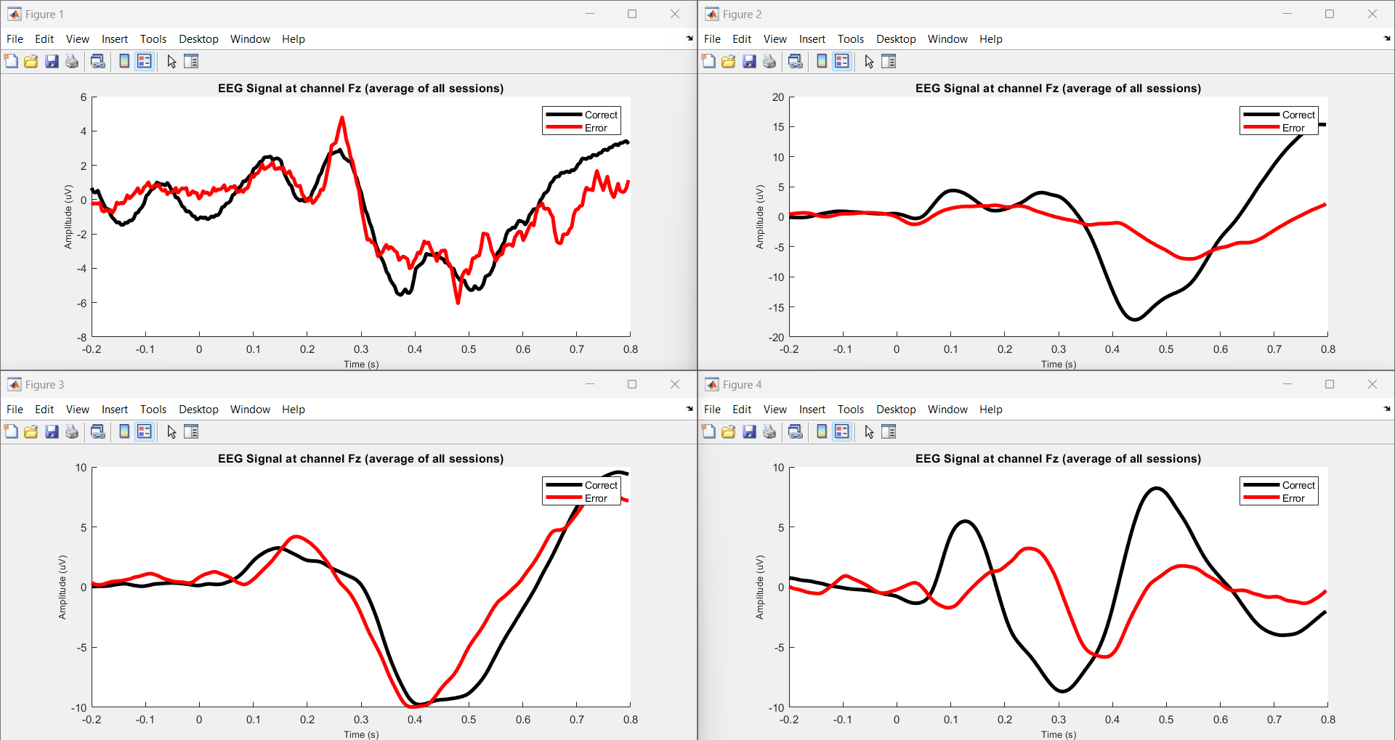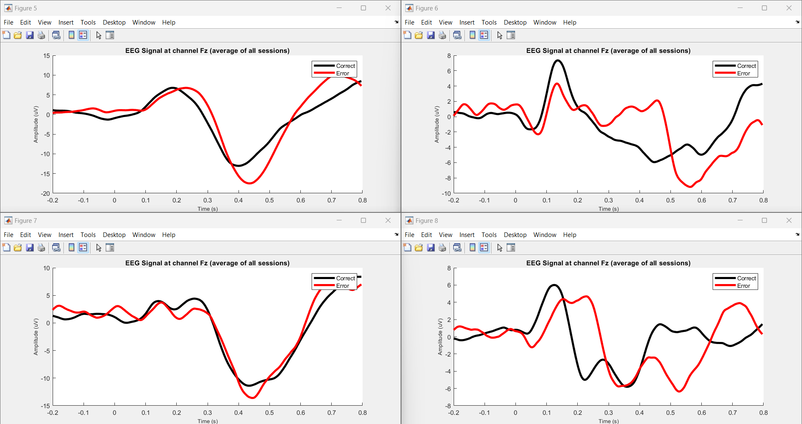

Fig 3.Errp pattern Recognition by using P300 based BCI speller.

The task investigates error-related potentials (ErrPs) and P300 event-related potentials (ERPs) in EEG data, particularly focusing on human-robot interaction (HRI). EEG signals are acquired using an ActiCHamp amplifier, capturing brain activity during interactions with a humanoid robot in a simplified task. Preprocessing involves filtering EEG data to extract relevant neural signals, followed by ErrP data extraction and labeling. The processed data, including participant IDs and session information, are stored for analysis. The project utilizes MATLAB for data processing and visualization, including plotting average EEG signals at channel Fz for correct and error conditions. This analysis aids in understanding neural responses to robot-induced errors, facilitating adaptive behavior and real-time feedback. The task aims to improve human-robot interaction by enabling robots to adjust behaviors based on neural responses, enhancing the efficiency and reliability of the interaction process.

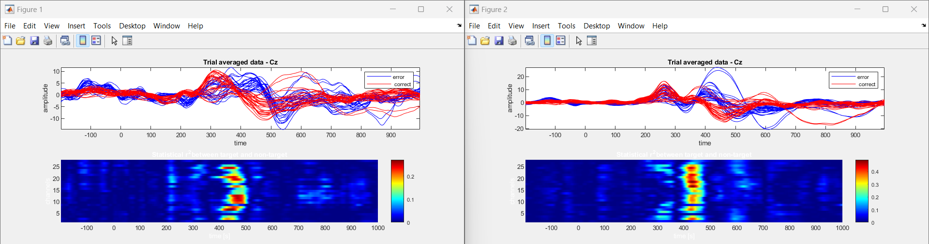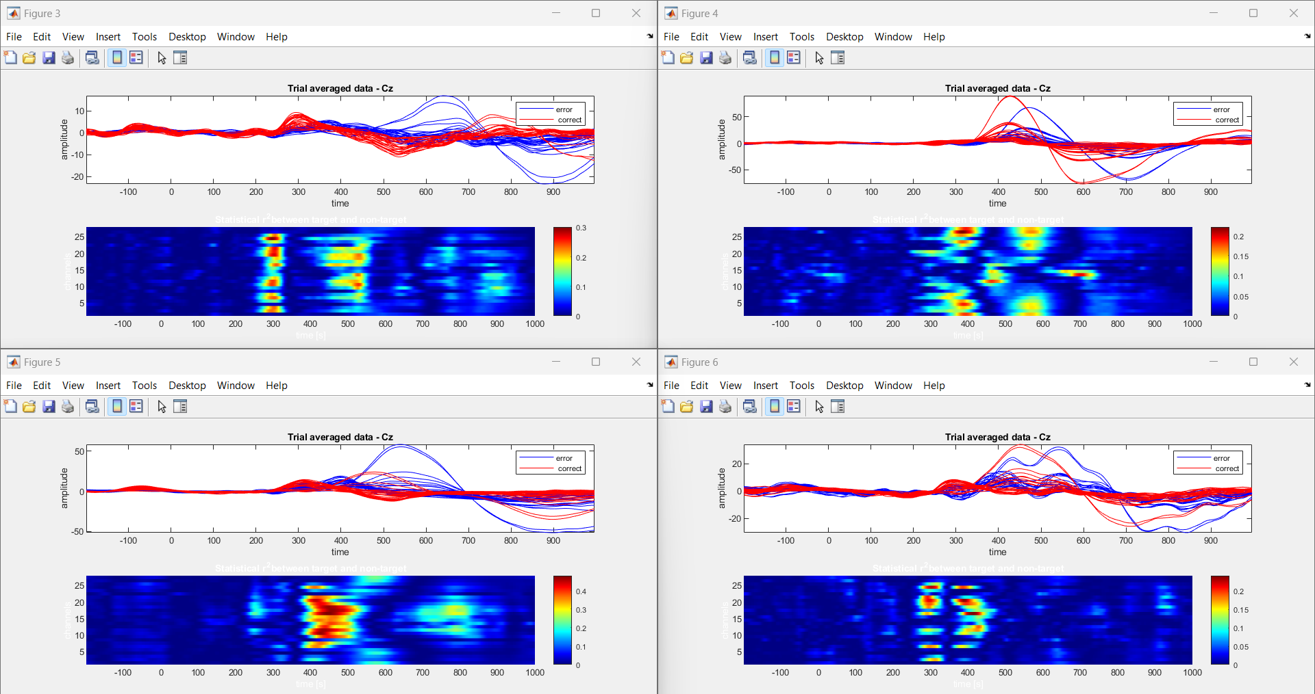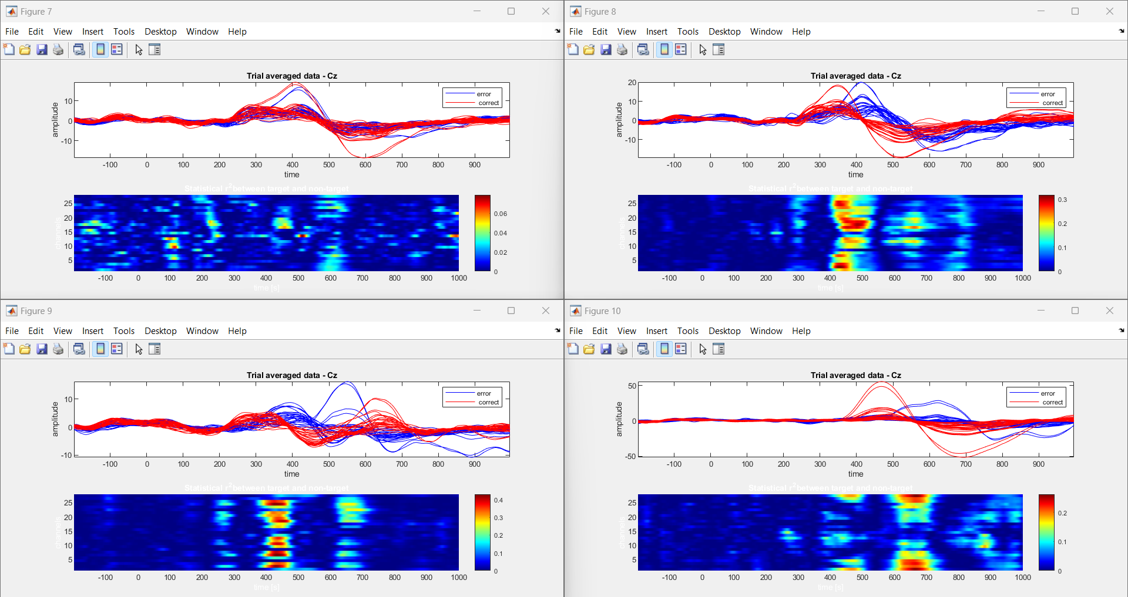

Fig 4. Errp pattern Recognition by using Human-Robot interaction task (Fostering Human-Agent Co-Adaptation Through Error-Related Potentials)

In "Human-agent Co-adaptation using Error-related Potentials", participants engaged in a guessing game with a robot partner. EEG data was acquired during two main phases: a calibration session and closed-loop co-adaptation sessions. The calibration session involved participants guessing the robot's chosen object, while closed-loop sessions continued this interaction. EEG signals were analyzed to decode error-related potentials (ErrPs), indicative of participant's error perception. The robot's behavior adapted based on these decoded ErrPs, fostering human-agent co-adaptation. Data analysis involved preprocessing EEG signals, extracting features, and decoding ErrPs for real-time feedback. Graphical analysis of ErrPs provided insights into participants' error perception dynamics, facilitating adaptive behavior in the robot. Overall, the task aimed to enhance human-agent collaboration through real-time neural signal processing, paving the way for more intuitive and efficient human-robot interaction paradigms.